**Project phase one**

**List of features**

1.Login and Registration

**Responsibility –** Olga

**Brief description -**

-The user can register and login in order to access the site

**programming logic - input, process and output (flowchart)**



2. Gainers and Losers

**Responsibility –** Enrina

**Brief description -**

-Classification of stocks will be done on the basis of their value change in the table using API.

**programming logic - input, process and output (flowchart)**

[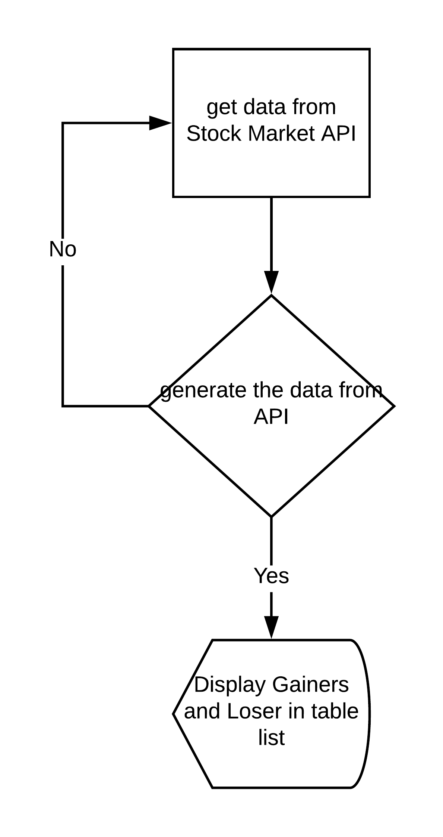](https://www.lucidchart.com/documents/edit/dcb5fd45-2511-4f99-86a8-38262295bfa4/0?callback=close&name=docs&callback_type=back&v=250&s=595.4399999999999)

3. Portfolio

**Responsibility** – Kenneth

**Brief description -**

-The user can add/remove stocks into their portfolio from the available stocks.

**programming logic - input, process and output (flowchart)**

[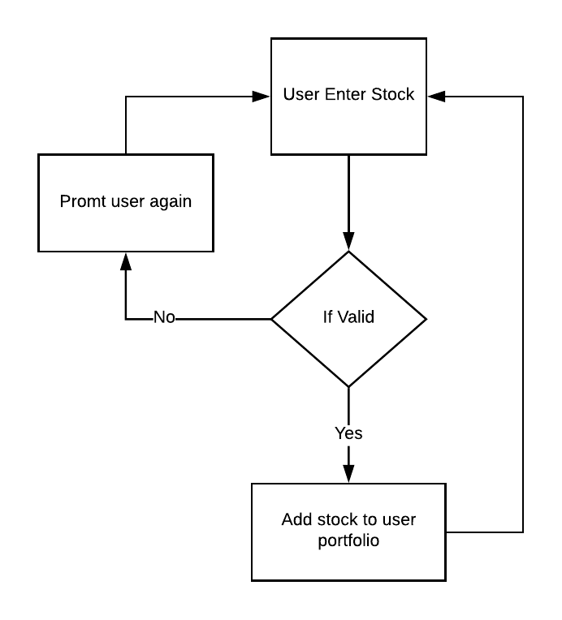](https://www.lucidchart.com/documents/edit/42617a20-bdcc-4554-9c0f-c8a466ee777b/0?callback=close&name=docs&callback_type=back&v=286&s=346)

4. Watchlist

**Responsibility –** Yash

**Brief description -**

-The user can create a watchlist for selected stocks to keep track of them. Give them an option to add it to the portfolio.

-The user will get a choice to select stock on the basis of a particular stock market.

**programming logic - input, process and output (flowchart)**

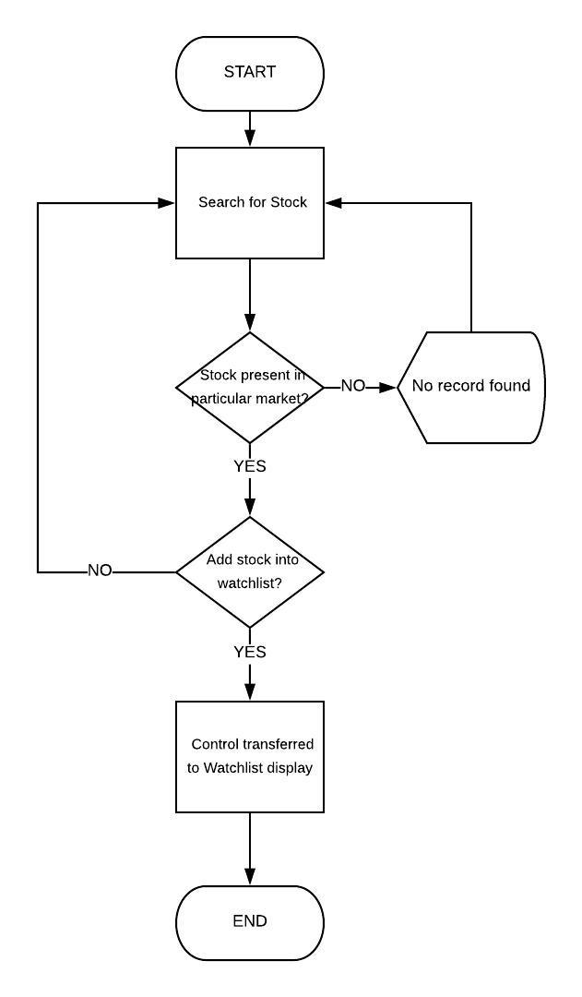

5. Search

**Responsibility –** Kenneth

**Brief description -**

This feature will help the user to search for a particular stock on the basis of industry, stock name etc.

**programming logic - input, process and output (flowchart)**

[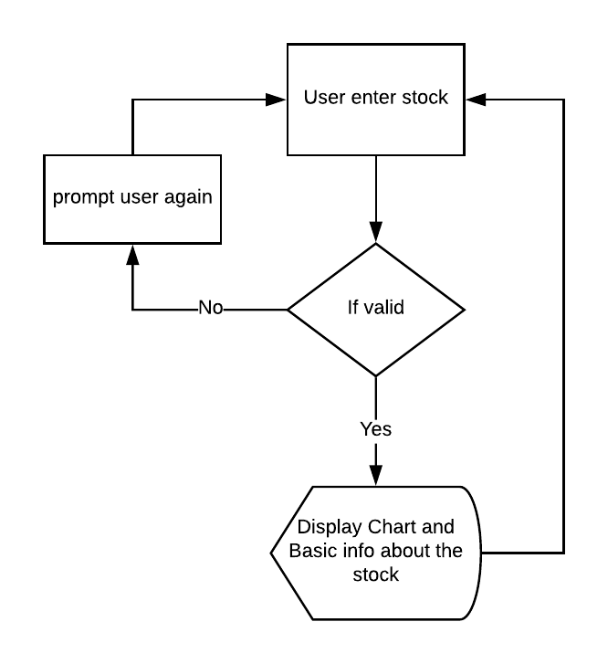](https://www.lucidchart.com/documents/edit/97f39067-eb9c-47e2-abdd-6479327259c8/0?callback=close&name=docs&callback_type=back&v=336&s=333)

6. Projection Chart

**Responsibility –** Lawrence

Tier 3

**Brief description -**

-This feature will display data about particular stock or industry in terms of change in value for a required timeline. Data will be present in Chart.

-This is according to a particular portfolio

Note: - we can use third party chart.

**programming logic - input, process and output (flowchart)**

[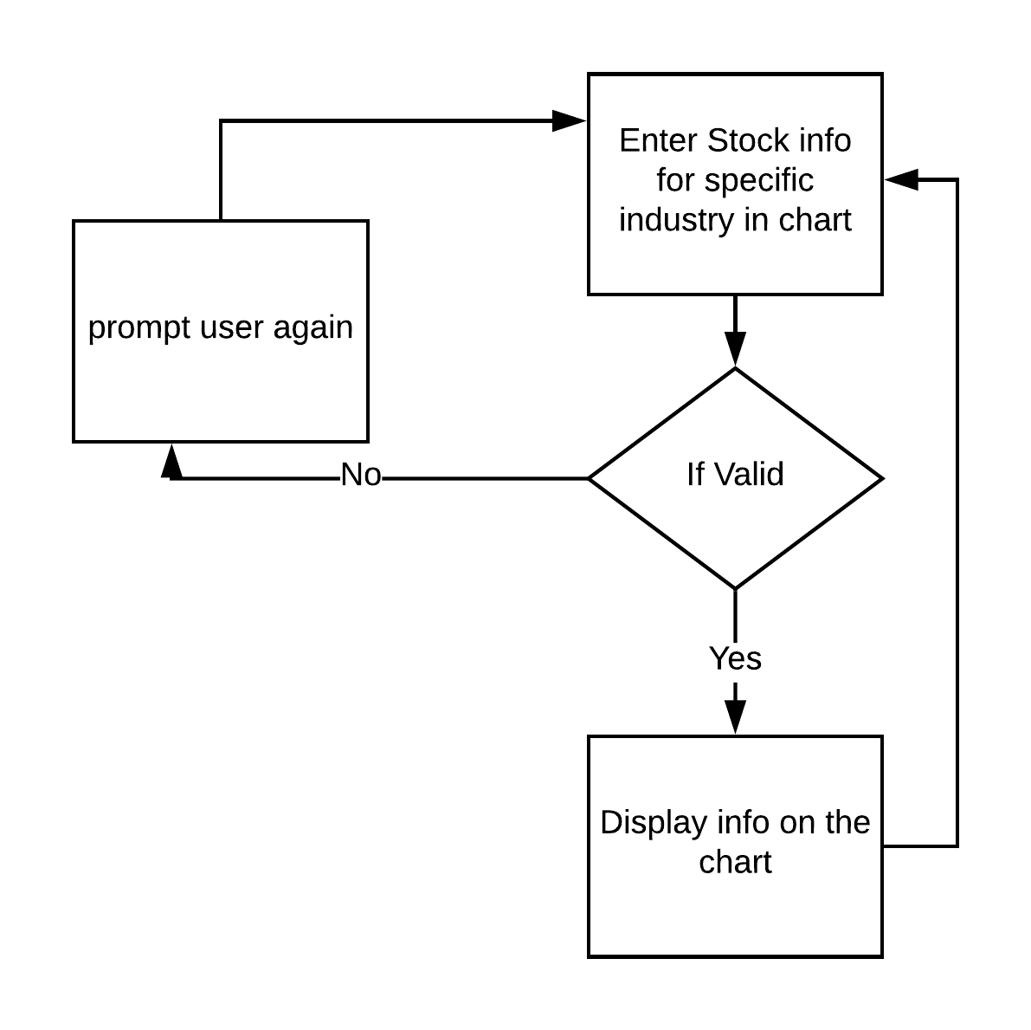](https://www.lucidchart.com/documents/edit/4ef54efd-9134-4aad-88b5-1b31d281659b/0?callback=close&name=docs&callback_type=back&v=268&s=595.4399999999999)

7. Filter Search (Screener)

**Responsibility –** Olga

**Brief description –**

-The feature allows users fast search any information on the website

**programming logic - input, process and output (flowchart)**



8. FAQ

**Responsibility –** Lawrence

Tier 1

**Brief description -**

-Feature to submit a question for admin

-If there are common FAQ will be good otherwise people can ask many questions.

- At the bottom put a form.

**programming logic - input, process and output (flowchart)**

[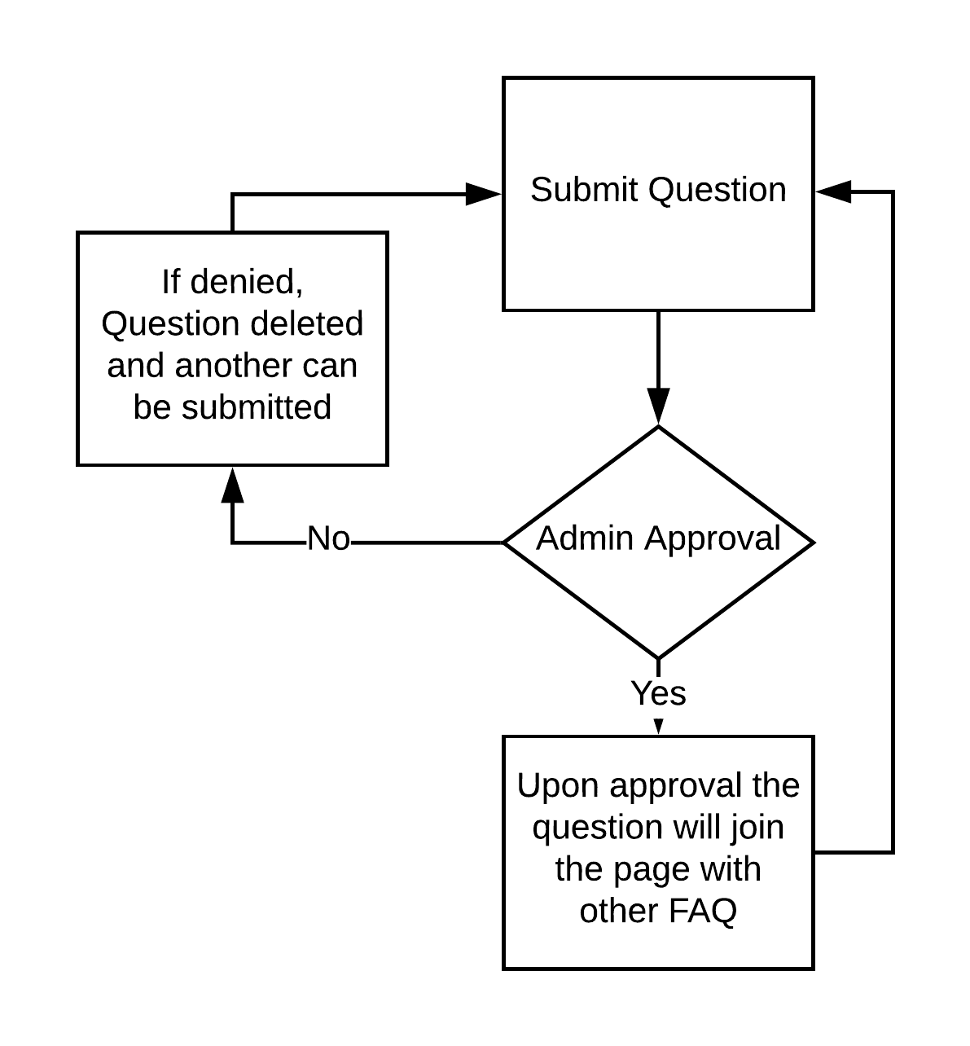](https://www.lucidchart.com/documents/edit/79a88787-6079-4bdb-b04b-047d4d9eb936/0?callback=close&name=docs&callback_type=back&v=318&s=595.4399999999999)

9. News (RSS feeds)

**Responsibility –** Enrina

**Brief description -**

-latest news

**programming logic - input, process and output (flowchart)**

[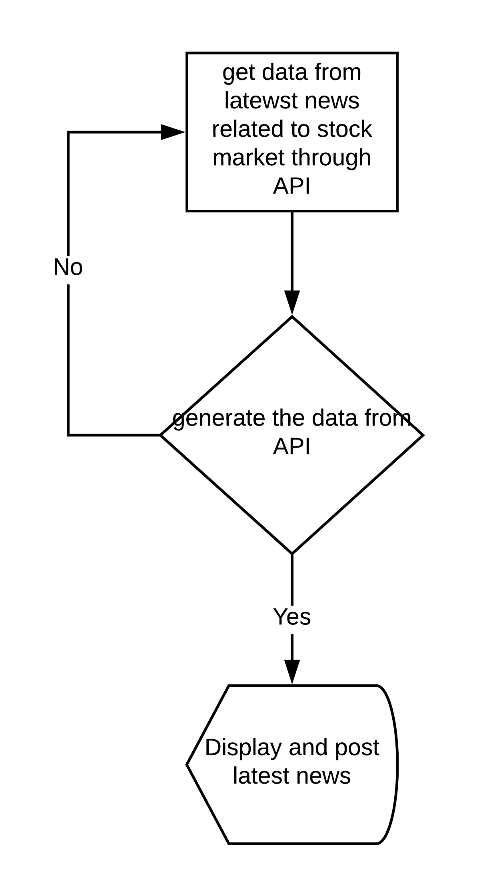](https://www.lucidchart.com/documents/edit/8a4d8b3b-1405-4e38-bae0-d231686ad09e/0?callback=close&name=docs&callback_type=back&v=186&s=595.4399999999999)

10. Blog

**Responsibility –** Yash

**Brief description -**

-For Public

**programming logic - input, process and output (flowchart)**

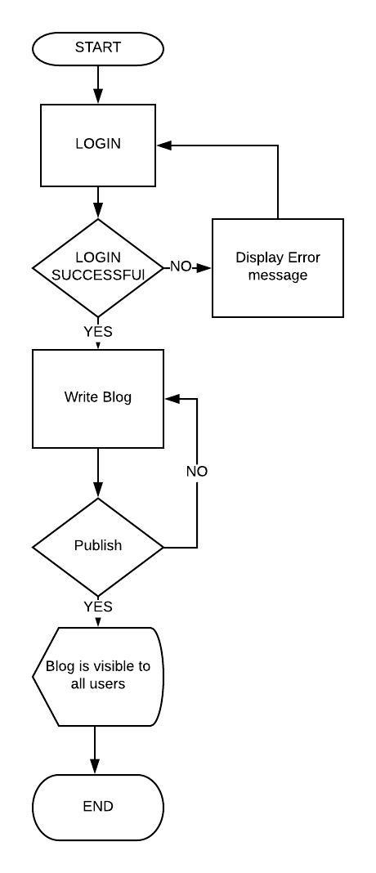

11. Contact us (To admin)

**Responsibility –** Olga

**Brief description –**

-Feature to submit a message for admin through the system without mail.

-The feature has the easy form to fill out

**programming logic - input, process and output (flowchart)**



12. Status sharing

**Responsibility -** Enrina

**Brief description -**

-Anyone can see the status of other.

-Try to provide a feature to filter the status

**programming logic - input, process and output (flowchart)**

[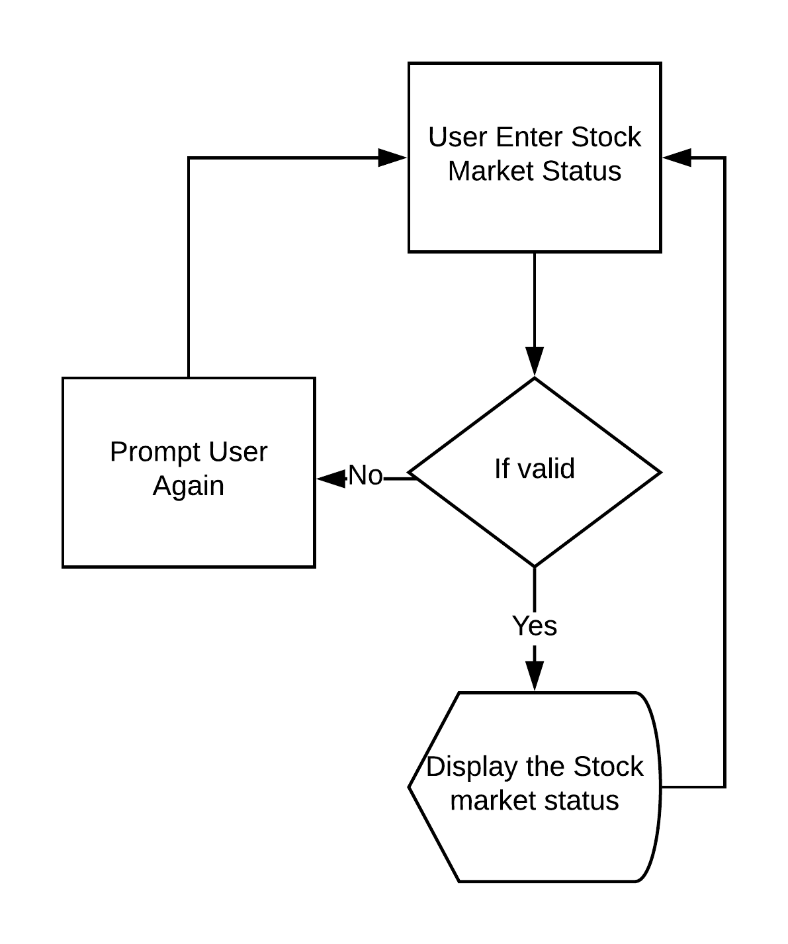](https://www.lucidchart.com/documents/edit/a00844ef-77db-4c04-a676-0f287999bac0/0?callback=close&name=docs&callback_type=back&v=261&s=595.4399999999999)

13. Stock chart

**Responsibility –** Kenneth

**Brief description:**

* The user can search for a stock ticker and the stock history will get displayed in a nice chart format in days.

**programming logic - input, process and output (flowchart)**

[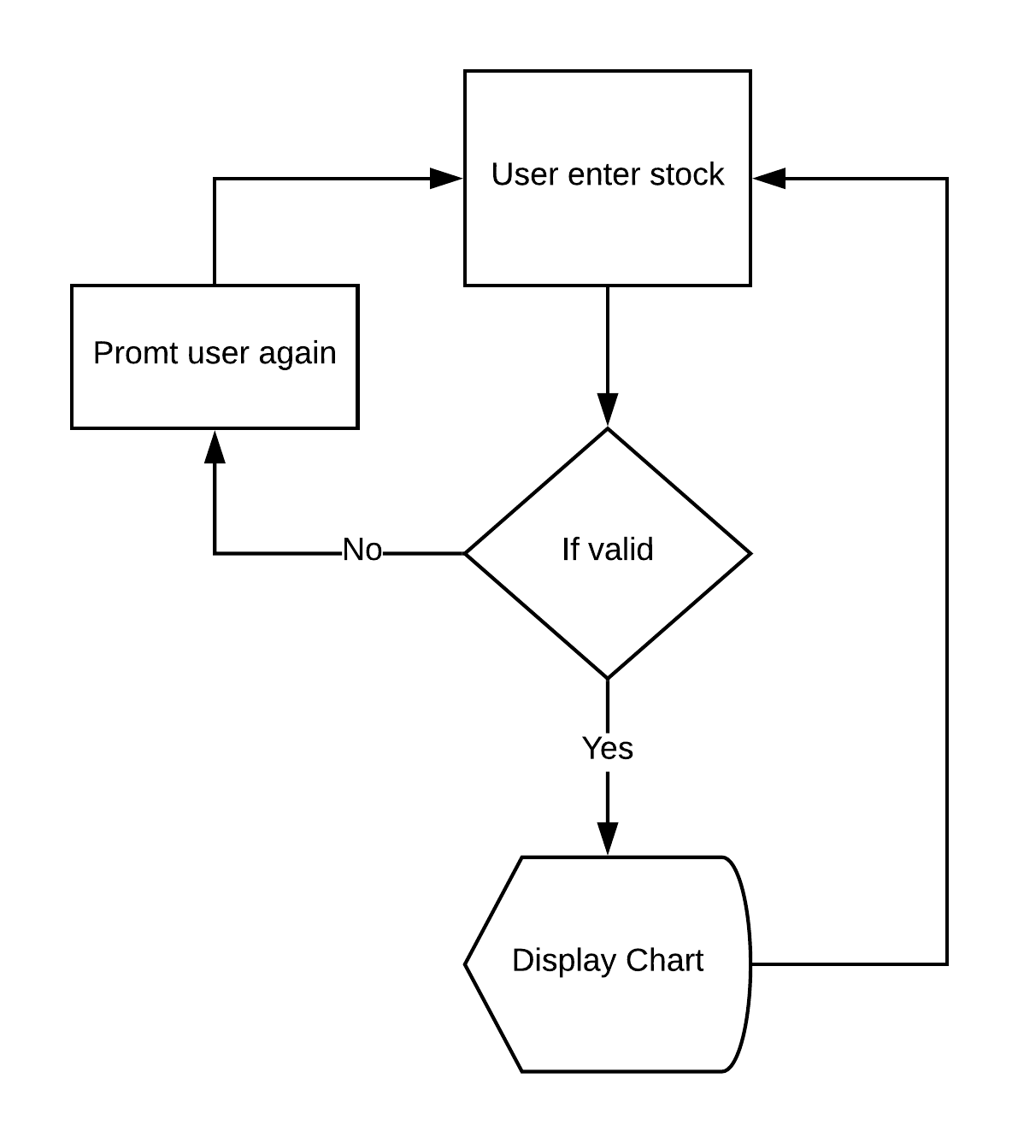](https://www.lucidchart.com/documents/edit/bcd406e0-3390-4b4b-b8d8-f7b6b1550f89/0?callback=close&name=docs&callback_type=back&v=338&s=595.4399999999999)

14. Events

**Responsibility -** Lawrence

Tier 2

**Brief description -**

-Admin has the functionality to add/update/delete events

**programming logic - input, process and output (flowchart)**

[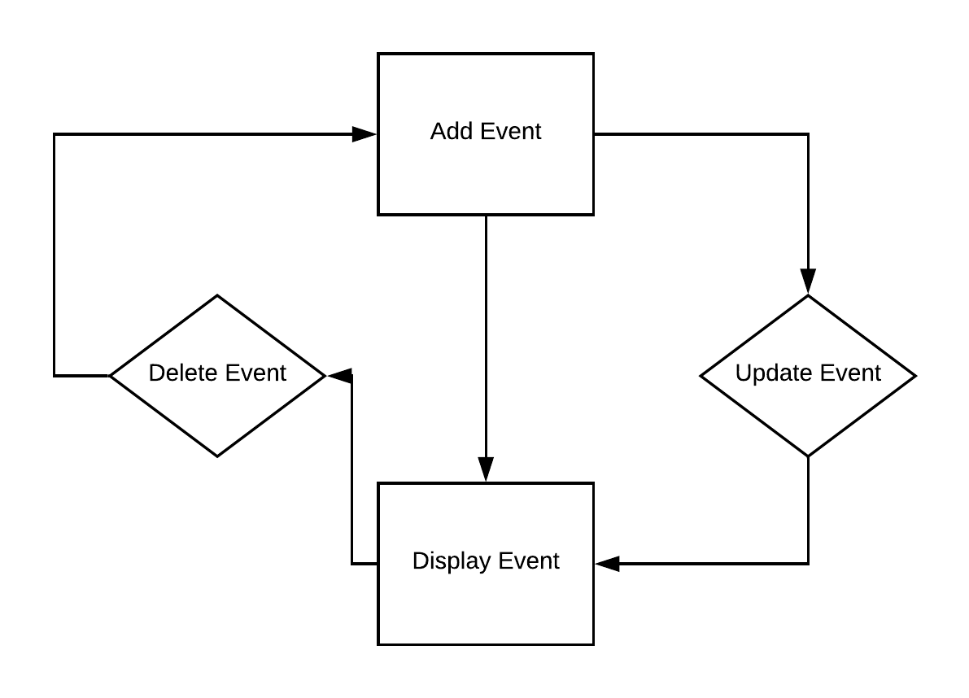](https://www.lucidchart.com/documents/edit/810545ac-d450-4788-95d7-72e2a4334a3d/0?callback=close&name=docs&callback_type=back&v=242&s=595.4399999999999)

15. Comment section

**Responsibility -** Yash

**Brief description –**

**programming logic - input, process and output (flowchart)**

